FOR IMMEDIATE RELEASE
May 20th, 2020

CONTACT: Mari Buttarazzi; mlbuttarazzi@gmail.com

Defending Main Street Super PAC Applauds Cliff Bentz For Primary Win After Pouring $225,000 Into His OR-02 Race

WASHINGTON - GOP super PAC Defending Main Street congratulates Cliff Bentz on his primary win in Oregon’s 2nd District.

“Cliff Bentz is the right man for the job,” said Sarah Chamberlain, Treasurer of Defending Main Street. “No one is better suited to follow Rep. Walden’s legacy of strong conservative values and civility in Congress. We look forward to seeing him cross the finish line in November.”

Defending Main Street previously released a six-figure television ad campaign supporting Bentz in his race to replace Rep. Greg Walden.

VIEW AD HERE: https://www.youtube.com/watch?v=a_nlfIEiHO0

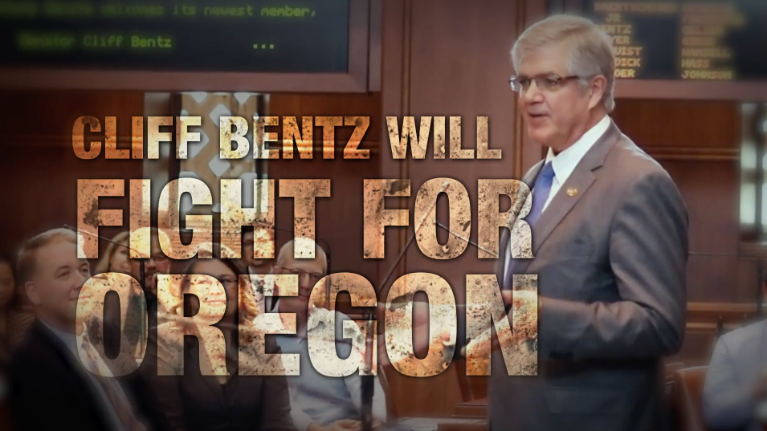

###

Defending Main Street, founded by the late Rep. Steve LaTourette, is the one of the most effective independent-expenditure organizations; defending existing governing republican seats and pushing new Main Street candidates to victory. In 2016, Defending Main Street won 11 of 12 of their general election contests, and in 2018 DMS won 5 out of 7 of the toughest general election races that cycle. For more information, visit defendingmainstreet.com.

