FOR IMMEDIATE RELEASE
April 23rd, 2020

CONTACT: Mari Buttarazzi; mlbuttarazzi@gmail.com

Defending Main Street Super PAC Drops $200,000 TV Ad Supporting Cliff Bentz in OR-02 House Race

WASHINGTON - GOP super PAC Defending Main Street released a six-figure ad campaign supporting Cliff Bentz for Congress.

“Cliff Bentz is a fierce advocate for the American economy who will fight to keep Oregon’s 2nd District working,” said Sarah Chamberlain, Treasurer of Defending Main Street. “No one knows this district and its values better than Bentz.”

VIEW AD HERE:https://www.youtube.com/watch?v=a_nlfIEiHO0&feature=youtu.be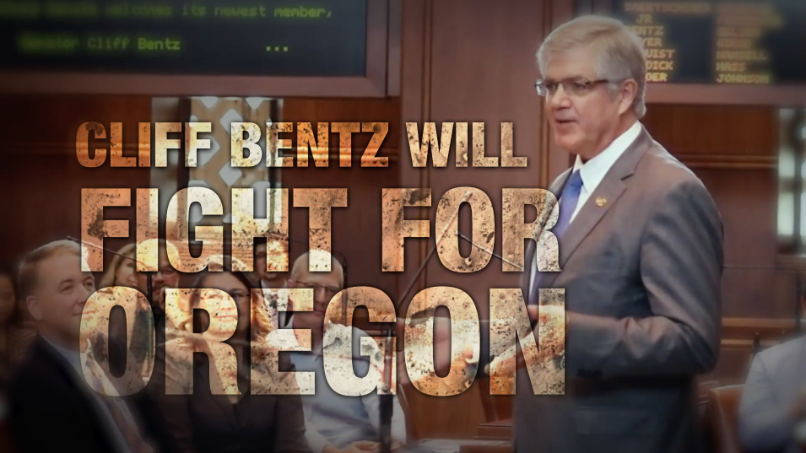

###

Defending Main Street, founded by the late Rep. Steve LaTourette, is one of the most effective independent-expenditure organizations; defending existing governing republican seats and pushing new Main Street candidates to victory. In 2016, Defending Main Street won 11 of 12 of their general election contests, and in 2018 DMS won 5 out of 7 of the toughest general election races that cycle. For more information, visit defendingmainstreet.com.

